Activity 24. Task Preferences! (EUC from STING project)
- Learning outcome(s):(list up to 3)
    - To highlight the nature of a task by considering its strengths and weaknesses in relation to gender balance in STEM activities.
    - To learn about the different parts of a vacuum cleaner, hair dryer or toy car.
    - Το learn about electric circuits and the direction of current, how to use batteries, small motors and (design) fans.
- Relation of activity with the STEM, gender inclusiveness and Entrepreneurship: (text, not bullets, explaining the relation of the activity to 3 above)
This is an activity to make teachers aware of the varied preferences of students whilst involved in making decisions for classroom tasks. In this activity, participants are asked to solve a problem by developing and improving a technology. They are asked to design and build their own vacuum cleaner, hair dryer or toy car. The participants generate creative solutions to a challenging problem and work like engineers. These tasks focus on STEM (Science, Technology, Engineering and Mathematics) practices and the relationships between STEM practices and concepts. Through such practical real-world connections, students have an opportunity to see how STEM is part of their everyday world.
- Indicate the area of focus:
☒ STEM
☐ Gender inclusiveness
☐Entrepreneurship
- Materials:(including ppts, videos, hands-on material)
- Pencil and paper for each participant
- Small motors 1,5-3V
- Batteries 4,5V or 3x1,5 V
- 3 x AA Battery Box
- Solid Core Wire
- Solid Core Wire resistance
- Plastic bottles from 0,5-2 litre and plastic bottle lids.
- Paper fasteners.
- Paper clips.
- Wire strippers.
- Pieces of cardboard 10 x 10 cm.
- Debris from a hole puncher.
- Glue pistol.
- CDs.
- Thick wood sticks or lollipop sticks
- Preparation:
None if solely performed as a design exercise, although if actual materials will be used, these materials should be prepared before implementation.
- Duration:60-90(minutes)
- Target group:10-15 years old (student age)
__________________________________________________________________________

- Description of the activity:
Group work - Groups of 4-5 students.
• Brainstorming: inquiry, planning and design, and drawing on a sheet (15 min).
• The building of a chosen artefact (30 min).
• Presenting their design/actual artefact to their classmates (15 min).
The activity ends with a plenary discussion. We explain students that when designing new items scientists often run a SWOT Analysis. We explain what SWOT means (Strengths, Weakness, Opportunities, Threats) and we have each group run a SWOT analysis for their design.
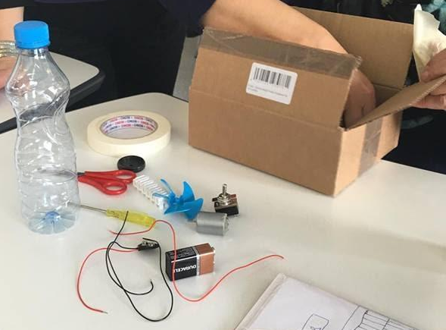

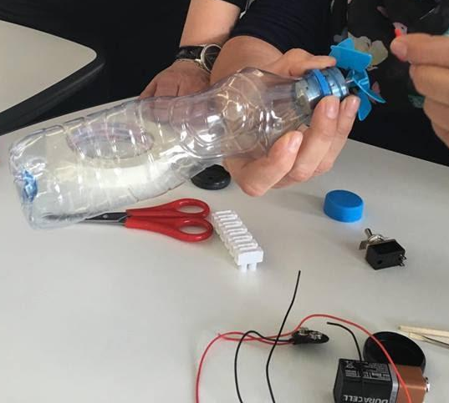
9. Link to curriculum:

